PGMMST Help Text Creation
Abstract
This document covers the automated help text creation built into the Program Master system. The Program Master system is part of APLLIB system.
Table of Contents
1 Introduction 2
1.1 Purpose 2
1.2 Scope 2
1.3 Definitions, Acronyms, and Abbreviations 2
1.4 References 2
1.5 Navigation 2
2 Styling [change] 3
2.1 New Section Spacing 3
2.2 Helpful Keyboard Shortcuts 3
3 Documentation Standards [remove] 4
3.1 Title Page/File Name 4
3.2 Table of Contents 4
3.3 Revision History 5
3.4 Footings 5
4 End User Documentation Standards 6
5 Dictionary Maintenance List [List Screen Example] 7
5.1 Fields 8
5.2 Columns 8
5.3 Selection Options 8
5.4 Function Keys 9
6 Dictionary Detail Screen [Regular Screen Example] 11
6.1 Fields 11
6.2 Function Keys 12
7 Revision History 13

Introduction
This document covers the automated help text creation built into the Program Master system. The Program Master system is part of APLLIB system.

Purpose
This document has been created to assist developers with setting up help text within the program master system. It is a supplemental document to the Program Master System document.

Scope
This document only cover the help text generation within the Program Master system.

Definitions, Acronyms, and Abbreviations
- APLLIB – A programming development library designed to increase programmer efficiency while ensuring consistent high quality programs.
- Program Master System (PGMMST) – A set of programs, service programs and template programs that create a standardized programming environment for IBM I development.

References
More information can be found in the GitHub repository at https://github.com/ttognazzini/APLLIB.

Help Text
Help text is entered in the PGMMST system. This system handles the management of programs. It provides a maintenance program to set SFL options, function keys, program actions and help text for programs. Currently it has a place holder for security as well, even though that has not been implemented yet.
When creating a new program, it is best to use the PGMMST system to copy an existing program. This copies over any command keys or SFL options from the existing program. It is also required to have an entry in the PGMMST file for the help system to work. This is because each display file mut have a HLPTITLE property and the automated help text system uses the program name from the PGMMST file for the title.
To get to the PGMMST main list screen use the command CALL PGMMSTD1 and press enter. This will bring up a list of all program setup in the system. It is best to use the search to limit the list to the program set you are working with. The following is an example of that screen filtered to the RCBQRY programs.
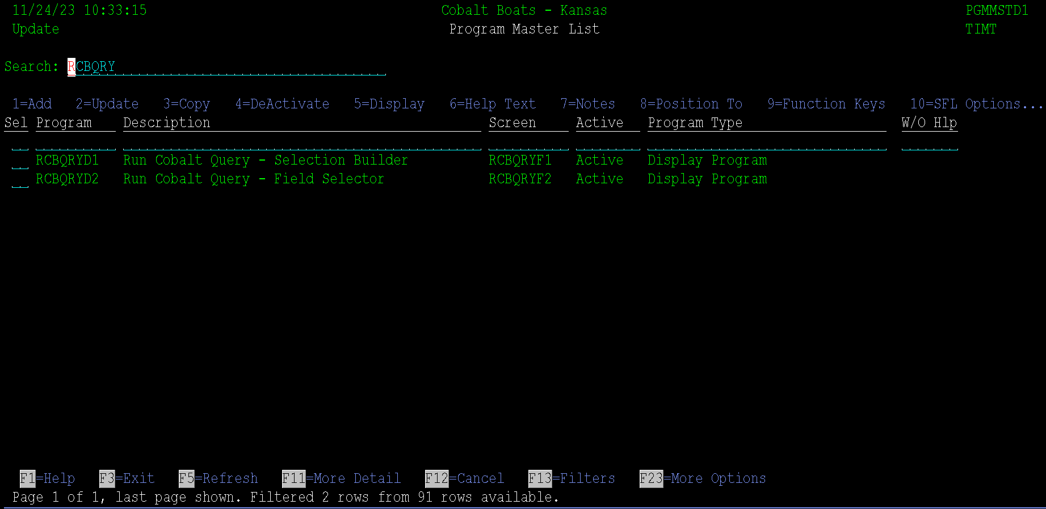
From this screen, option 6 can be used to work with the help text for a program. I couldn’t figure out how to get a table function into LMI, so for now CBTBASDEV must be in your library list to do this. That shouldn’t be an issue because all work should be done DEV anyways.
Using option 6 displays this screen:
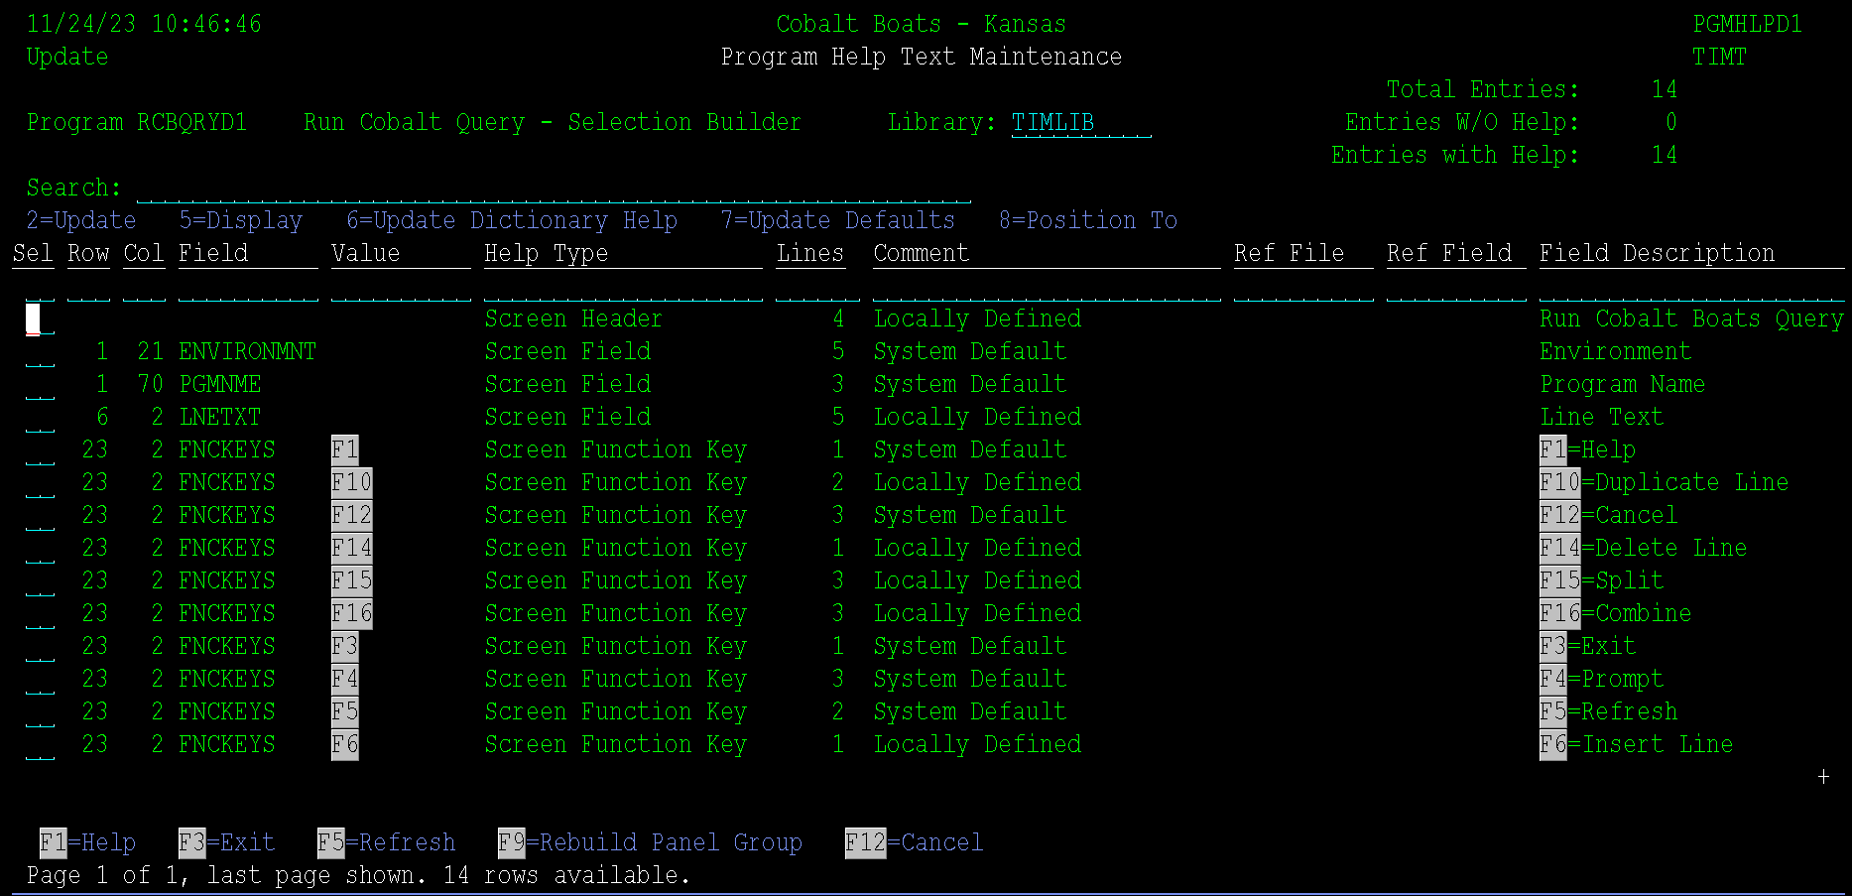
The screen displays all fields on the screen and adds an option for the header, SFL options and function keys. These fields are populated form the Display File Preprocessor program. Please review that section form more information.
Help text can be updated using option 2 in front of one of the entries. Each entry should have help text added for it. The entries can be separated to 4 different types. They are listed below and then each type has section with specific details about it.
- Screen Header
- Screen Field
- Screen SFL Option
- Screen Function Key

Screen Header
This is a special help text area setup for information about what the screen is used for. It setup in the display for position one of column 1, it is not intended to be displayed unless the extended help option is used. This should be pretty generic information. For example, the following screen shot is what it looks like in the extended help text for the RCBQRY Selection Builder screen:
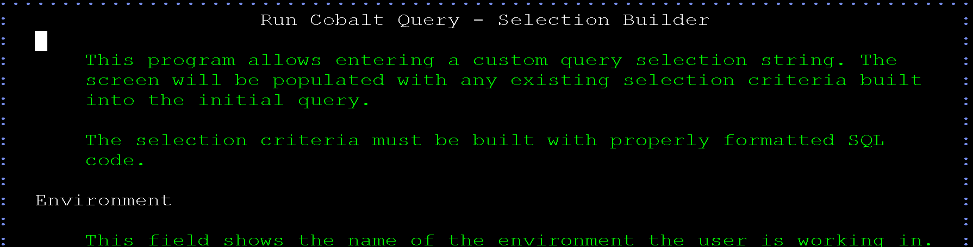
Using option 2 to update the help text for this displays the following screen:
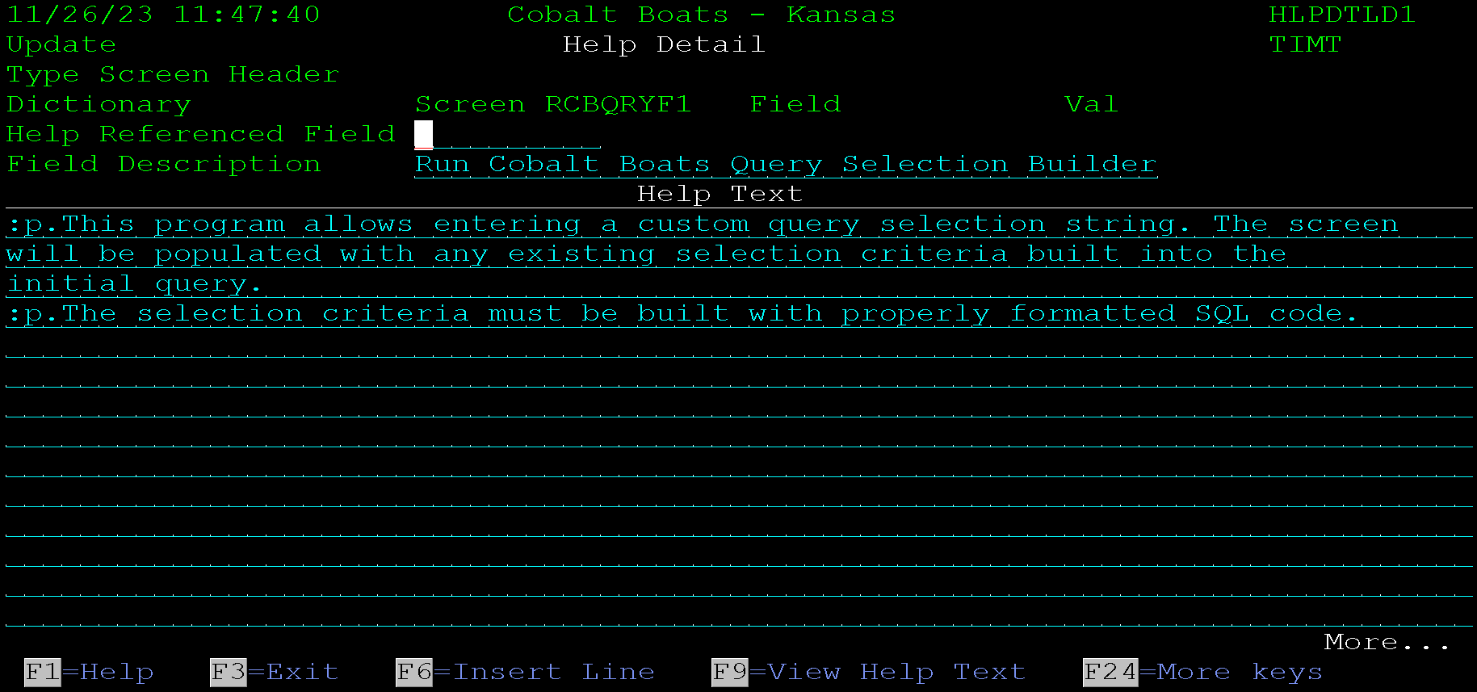
The field reference field should not be used on header screens. It allows the help text to be pulled from another field. The Field description must be filled in. This is the message that is displayed at the top of the help text.
The help text section of the screen is used to enter help text for the screen. The help text must bor formatted in PNLGRP format. The example above shows each paragraph starting with :p., this is the markup for a paragraph. This document will not cover PNLGRP markup, there are many resources on the internet that do cover it.

Screen Field
The program picks up all standard fields on the screen. The Display file preprocess adds the help functions needed to the display file for each filed and builds the help panel group source for each field.
There are 3 ways to add/use help text for a field. They are:
- Program Specific Help Text
- Dictionary Level Help Text
- System Default Help Text
The following sections discuss each way to add help text.

Program Specific Help Text
Program specific help text is help text entered for a field on a single screen. It will not used elsewhere. This is acceptable for custom fields that are only use in one program. If the field is a standard system or field referenced from the dictionary, one should use dictionary level help or System Default Help. These tow options allow the help text to automatically be displayed on other screens without having to be re-entered.
To add program specific help text, use option 2 in front of the field in the help text maintenance list.
Program specific help text is often used to overlay specific dictionary help if a field is used differently on a screen then it is intended to be used from the dictionary. For example, a report prompt screen may reference the item number field. The dictionary has all kinds of useful help text for the item number field, but on the report prompt screen the item number is being used as a selection field, so the help text should include information about the item number being used to filter the report instead of what an item is number is for in the general system.

Dictionary Level Help Text
Dictionary level help text is help text that applies to a field referenced from the dictionary. It will be displayed by default if program specific help text has not been specified for a field. This allows the field to have help text entered once and be used throughout the system. It prevents programmers from having to enter help text every time a field s used on a screen.
Continuing the item number example from the previous section, the dictionary help text for item number would discuss the size of the field and what an item number is used for. For most inquiry screens and the item master programs, this description will be sufficient without having to be augmented at the program level.
Dictionary level help is added using option 6=Update Dictionary Help in front of a field in the Program Help Text Maintenance screen.

System Default Help Text
The system default help text is the highest level help text that can be entered for a field. It is only displayed if there is not dictionary level help and there is no program specific help text. This is used from things that are common to programs in a system. Examples of these are the environment name used at the top of each screen, common function keys like F1 = Help or F3 = Exit, and common SFL Option like 2 = Update.
The system defaults can be overridden if needed at the dictionary or program level, so adding the for most common SLF options and command keys is encouraged.
System Default help text is added using option 7=Update Defaults in front of an entry on the Program Help Text Maintenance screen.
All help text must be entered as properly formatted UIM text.

Screen SFL Option
Fields listed as Screen SFL options are pulled from the SFL option entered for the program. These go in their own help section so formatting on them is a little different. The text is added after a preformatted un-ordered list with the option text already included in white. The programmer only needs to enter the text that goes next to the option. This means the text is not entered with any UIM markup.
SFL option help text can be entered at a program specific or system default level. Since SFL options are never referenced from the dictionary, they cannot use dictionary level help text.
SFL option help is displayed when the cursor is on the Options field, which is the line above the SFL in blue that the SFL options are loaded into, or if the cursor is on the selection field in the list, or if the extended help feature of the help prompt program is used.
The SFL options help text looks like this:
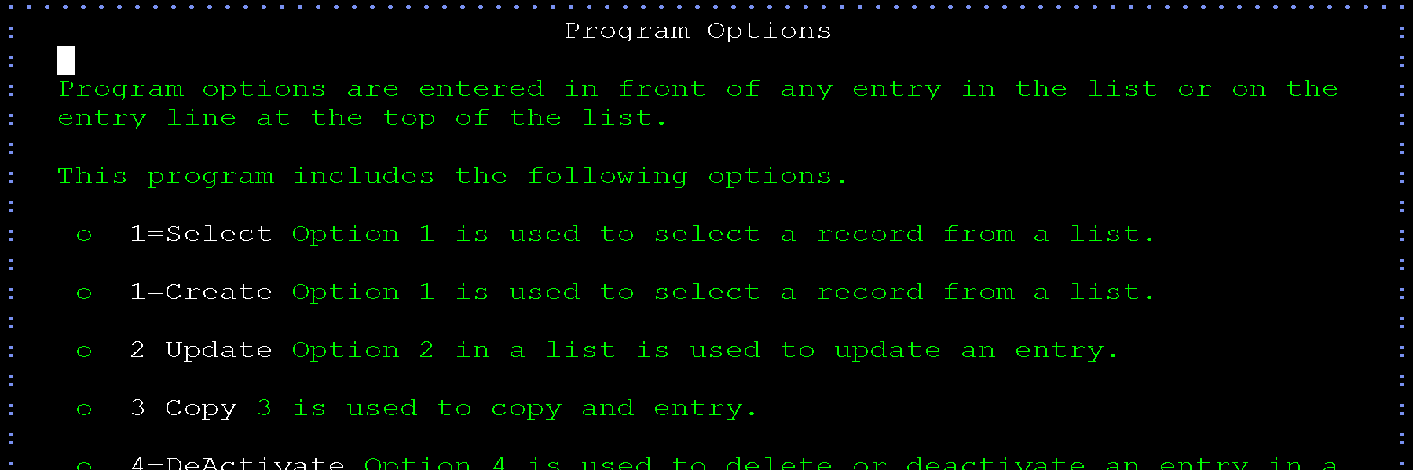
Event though the format is a list, only the green text after each entry is entered in the help panel.
For instance, the help screen for 2=Update in the above list looks like this:
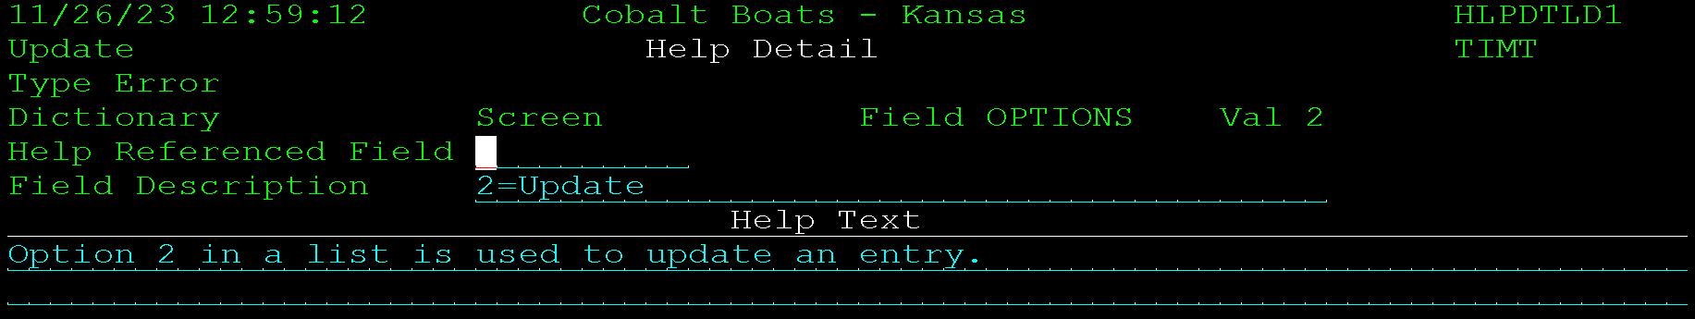

Screen Function Key
The screen function keys are like SFL options. They are listed as a list with the function key already populated from the function keys setup for the program. Theya re also listed in an un-ordered list with the key in white. So, the text entered for the function key does not need UIM formatting added.
Help text for function keys are displayed when pressing F1 with the cursor on the function key line, or by using the extended help feature for the screen.
Help text for function keys cannot be set at the dictionary level since they do not reference a dictionary field. Standard function keys should be defined at the system level, then program specific values can be used t override them as needed.

Revision History
Date | Document  Version | Description | Owner | Reason for Change
2026-06-07 | V1.0 | Initial draft | Tim Tognazzini

